Major Project Report

**Facial recognition using neural networks with image segmentation by DPSO**

2014-15

Aditya Gourav

Akshit Gupta

Arushi Kataria

Abstract

Image segmentation has been widely used in the document image analysis for the extraction of some printed characters, early map processing in order to find lines as well as characters, topological features for extraction of geographical information, and quality inspection of those materials where defective parts must be delineated among many other applications. In image analysis, the efficient segmentation of images into meaningful objects is important for classification and object recognition. We use the Darwinian Particle Swarm Optimization (DPSO) for determining the n-1 optimal n-level threshold on a given image. We therefore feed these segmented images to the neural network which trains on them and hence, efficiency is greatly increased.

Main Idea

Image segmentation is used by the neural network to train on the segmented images and hence, greatly reduce the computation complexity and increase the efficiency, as opposed to non-segmented image processing using neural networks.

Image Segmentation

Image division is the methodology of sending an advanced picture into numerous areas. As it were, image division could dole out a mark to every pixel in the picture such that pixels with the same name impart certain visual attributes. These items

contain more data than individual pixels since the translation of pictures focused around pixels is more important than that focused around individual pixels. Image segmentation is really important and used in the examination and understanding of pictures, therefore being broadly utilized for further picture handling purposes, for example, order and item distinguishment.Image division can be ordered into four separate sorts including composition examination based strategies, histogram thresholding based techniques, grouping based routines and locale based part and blending systems.

* Optimised Histogram Thresholding

Ideal limits are those which make the thresholded classes on the histogram achieve the wanted qualities. Normally, it is

made by improving a certain target capacity.

A few calculations have been proposed in writing that tended to the issue of ideal thresholding. While a large number of them address the issue of bi-level thresholding, others have considered the multi-level issue. The issue of bi-level thresholding is diminished to an improvement issue to test for the limit t that amplifies the and minimizes it.For two level thresholding, the issue is comprehended by discovering T*which fulfills max. Here L is the most extreme power esteem. This issue could be reached out to n-level edge utilizing comprehensive inquiry strategy. The comprehensive inquiry strategy focused around the Otsu rule.

* Otsu criterion ( Computationally expensive)

Comprehensive quest for n-1 ideal limits includes assessments of wellness of n(l n + 1)n1 mixes of edges. The errand of deciding n-1 ideal edges for n-level picture thresholding could be planned as an issue enhancement issue. Multilevel division methods give an effective approach to perform picture examination. Nonetheless, the programmed choice of a powerful ideal n-level edge has remained a test in picture division. This area shows a more exact plan of the issue, presenting some essential documentation:

May there be L force levels in every RGB (red-green–blue)

segment of a given picture and these levels are in the extent {0,1,2,...,l 1}. At that point one can characterize:

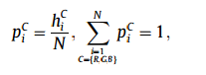

where i speaks to a particular power level, i.e.,

C speaks to the part of the picture, i.e., C = R,g,b},n speaks to the aggregate number of pixels in the picture and hc

i means the quantity of pixels for the relating force level i in the segment C. As it were, hci speaks to a picture histogram for every segment C, which can be standardized and viewed as the likelihood dispersion pc i . The aggregate mean (i.e., joined mean) of every segment of the picture can be effectively figured as:

The 2-level thresholding can be reached out to non specific n-level thresholding in which n 1 edge levels t :C

j ; j ¼ 1; ... ; n 1, are vital and where the operation is executed as communicated beneath

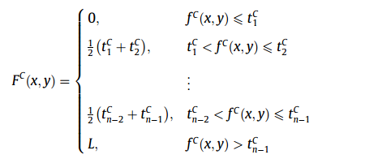

The simplest and computationally most efficient method of

obtaining the optimal threshold is the one that maximizes the between-class variance which can be generally defined by:

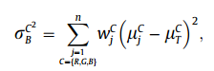

Where the probabilities are as follows:

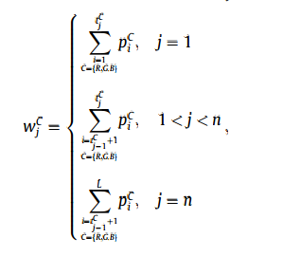

* Efficiency Improvement(Particle Swarming Optimization)

The computational time is one of the most important indicators along with fitness value which determine the ability of the algorithm. The PSO basically takes advantage of the swarm intelligence concept, which is the property of a system whereby the collective behaviors of unsophisticated

agents that are interacting locally with their environment, create coherent global functional patterns. Imagine a flock of birds where each bird cries at an intensity proportional to the amount of food that it finds at its current location. At the same time each bird can perceive the position of neighboring birds and can tell which of the neighboring birds emits the loudest cry. There is a good chance that the flock will find a spot with the highest concentration of food if each bird follows a trajectory that combines three rules: (i) keep flying in the same direction; (ii) return to the location where it found the highest concentration of insects so far; and (iii) move toward the neighboring bird that cries the loudest.

* Greater efficiency(Darwinian Particle Swarming Optimization)

However, a general problem with the PSO and other optimization algorithms is that of becoming trapped in a local optimum such that it may work well on one problem but may fail on another problem. In order to overcome this problem many authors have suggested other adjustments to the parameters of the PSO algorithm combining fuzzy logic (FAPSO) where the inertia weight w is dynamically adjusted using fuzzy ‘‘IF–THEN’’ rules or Gaussian approaches (GPSO) where the inertia constant w is no longer needed and the acceleration constants q1, q2 and q3 are replaced by random numbers with Gaussian distributions.

Each swarm individually performs just like an ordinary PSO algorithm with rules governing the collection

of swarms that are designed to simulate natural selection. Despite the similarities between the PSO and GAs, like randomly generated population, fitness function evaluation, population update, search for optimality with random techniques and not guaranteeing success; PSO does not use genetic operators like crossover and mutation:-

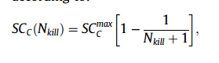

**Introduction to Artificial neural:**

Classification is one of the most frequently encountered decision making tasks of human activity. A classification problem occurs when an object needs to be assigned into a predefined group or class based on a number of observed attributes related to that object.

In machine learning and related fields, artificial neural networks (ANNs) are computational models inspired by biological neural networks, the neurons of our brain (the central nervous systems of animals, in particular the brain) and are used to estimate or approximate functions that can depend on a large number of inputs and are generally unknown. Artificial neural systems are for the most part displayed as frameworks of interconnected "neurons" which can process values from inputs, and are equipped for machine adapting and additionally pattern recognition on account of their versatile nature.

Examinations of the human's central sensory system motivated the idea of neural systems. In an Artificial Neural Network, basic artificial hubs, known as "neurons", "neurodes", "transforming components" or "units", are joined together to structure a system which impersonates a natural neural system.

There is no single formal meaning of what a artificial neural system is. Be that as it may, a class of statistical models might generally be called "Neural" on the off chance that they have the accompanying characteristics:

1. consist of sets of adaptive weights, i.e. numerical parameters that are tuned by a learning algorithm, and
2. are capable of approximating non-linear functions of their inputs.

The adaptive weights are conceptually connection strengths between neurons, which are activated during training and prediction.

Neural networks are similar to biological neural networks in performing functions collectively and in parallel by the units, rather than there being a clear delineation of subtasks to which various units are assigned. The term "neural network" usually refers to models employed in statistics, cognitive psychology and artificial intelligence. Neural network models which emulate the central nervous system are part of theoretical neuroscience and computational neuroscience.

Neural networks have emerged as an important tool for classification.

The advantage of neural networks lies in the following theoretical aspects. First, neural networks are data driven self-adaptive methods in that they can adjust themselves to the data without any explicit specification of functional or distributional form for the underlying model. Second, they are universal functional approximators in that neural networks can approximate any function with arbitrary accuracy. Since any classification procedure seeks a functional relationship between the group membership and the attributes of the object, accurate identification of this underlying function is doubtlessly important. Third, neural networks are nonlinear models, which makes them flexible in modeling real world complex relationships. Finally, neural networks are able to estimate the posterior probabilities, which provides the basis for establishing classification rule and performing statistical analysis.

The most important part on neural network is learning and generalization.

Neural networks are able to learn by training them with the training dataset and are able to predict even the input which it hadn’t seen before (generalization). This is the feature that sets neural networks apart.

We used sigmoid function in neural networks. The main reason for using sigmoid function in neural network is that it is differentiable.

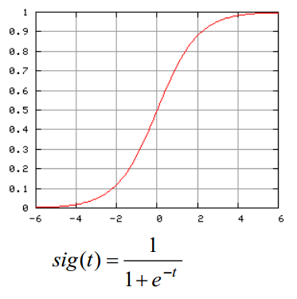

The sigmoid function introduces non-linearity in the network. Without it, the net can only learn functions which are linear combinations of its inputs. The result is called universal approximation theorem or Cybenko theorem.

The reason why you would use a sigmoid as opposed to something else is that it is continuous and differentiable, its derivative is very fast to compute (as opposed to the derivative of tanh, which has similar properties) and has a limited range (from 0 to 1, exclusive).

We need a cost function. The cost function will punish the neural network for wrong results (a higher value).

We used the standard cost function:

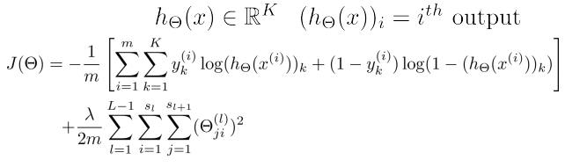

Which we get from logistic regression formulas:

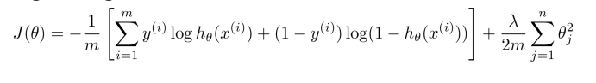

Backpropagation is used to backpropagate the errors so that we can calculate what the errors were there in the hidden layers.

It has two phases: propagation and weight update.

# Results:

The segmentation of the following image was:

original

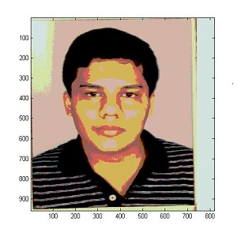segmented image

 original

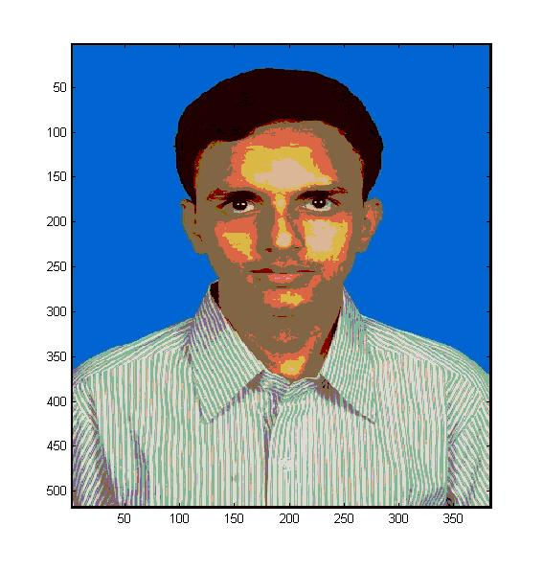segmented

A training dataset was taken, segmented and trained with the neural networks to get a better accuracy than when neural networks were trained on just the images.

Training images:

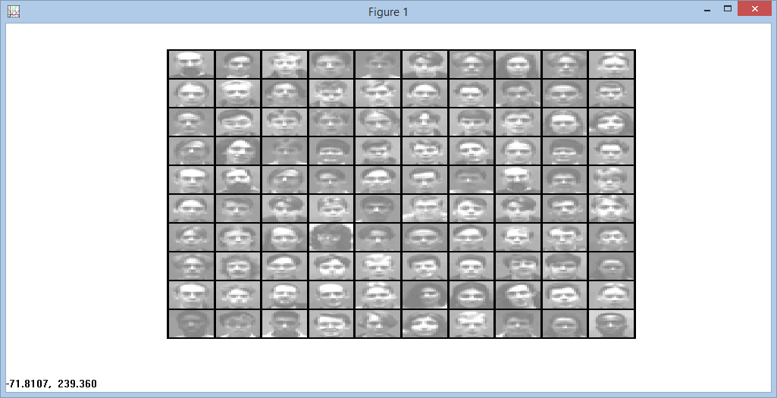

Hidden layer:

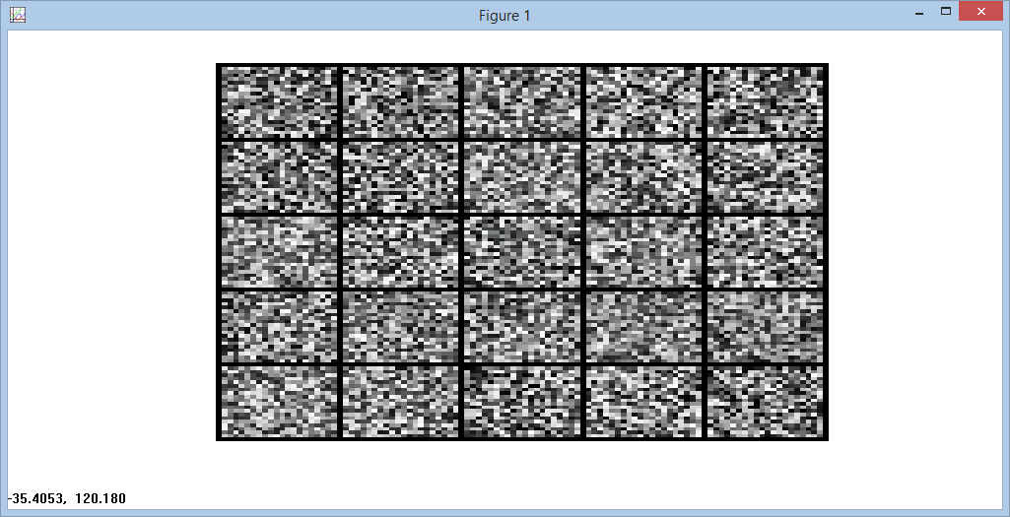

Also a simple to use UI was made for face recognition and image segmentation:



**Future Work:**

We can also use gabor features and other features such as eigen vectors for feature extraction and then train on the features, this will further increase the accuracy of the system.